BDO India LLP
Software Requirements and Specifications (SRS) Report of Beneficiary Management System (BMS) – PRAGATI SETU 1.0 Dated: 20th October 2025
U.P. State Rural Livelihoods Mission Lucknow, Uttar Pradesh







Document Details
Project Name | Beneficiary Management System (BMS-PRAGATI SETU 1.0)
Date: | 18-10-2025 | Release | Final Ver 1.0
Author | Ayush M Srivastava
Owner | BDO India LLP
Client | U. P. STATE RURAL LIVELIHOODS MISSION
Document Number | BDO-UPSRLM-SRS-v1-BMS’2025

Approvals
Name | Title | Date of Issue | Version
Sachin A Kumar | Project Manager-BDO India LLP | 20-10-2025 | 1.0
Team BDO | BDO India LLP |  | 1.0

Distribution
Name | Title | Date of Issue | Version
Ms. Deepa Ranjan | Mission Director (MD), UPSRLM | 20-10-2025 | 1.0
Mr. Niti Shrivastav | Joint Mission Director (JMD), UPSRLM | 20-10-2025 | 1.0

Table of Contents
1. Introduction 5
1.1. Purpose 5
1.2. Scope 5
1.3. Definitions, Acronyms and Abbreviations 6
1.4. Document Conventions 6
1.5. Intended Audience 6
1.6. Product Perspective 7
2. OVERALL DESCRIPTION 8
2.1. Product Perspective 8
2.2. Product Functions 8
2.3. User Classes and Characteristics 8
2.4. Operating Environment 9
2.5. Design and Implementation Constraints 9
2.6. Assumptions and Dependencies 9
3. SYSTEM CONTEXT AND ARCHITECTURE 10
3.1. System Context 10
3.2. External Interfaces 10
3.3. User Interface Overview 10
4. SYSTEM FEATURES 11
4.1. FRONTEND REQUIREMENTS 11
4.1.1. General UI Requirements 11
4.1.2. Accessibility 11
4.1.3. Navigation 11
4.2. ER – Diagram 12
5. DATABASE REQUIREMENTS 13
5.1. SYSTEM WORKFLOWS 13
5.1.1. LokOS Sync Workflow 13
5.1.2. Field Enrichment Workflow 13
6. FUNCTIONAL REQUIREMENTS (BMS) 14
6.1. FR-AUTH 14
6.2. FR-BMS-01 Beneficiary Retrieval 14
6.3. FR-BMS-02 Beneficiary Profile 14
6.4. FR-BMS-03 Data Enrichment 14
6.5. FR-BMS-04 Cross-Module Visibility 14
7. NON-FUNCTIONAL REQUIREMENTS 15
7.1. DATA AND DATABASE REQUIREMENTS 15
7.2. INTERFACES AND INTEGRATION 15
7.2.1. Authentication & users 15
7.2.2. Master data (location hierarchy & SHGs) 16
7.2.3. Beneficiaries 16
7.2.4. CONSTRAINTS & STANDARDS 17
8. ERROR HANDLING 18
8.1. AUDIT & LOGGING 18
9. DEPLOYMENT REQUIREMENTS 19
9.1. VALIDATION & ACCEPTANCE 19
9.2. CLOSURE 19

- Introduction
  - Purpose
This Software Requirements Specification (SRS) defines all functional, non-functional, technical, and integration requirements for the Beneficiary Management System (BMS) under Pragati Setu – Combined Dashboard v1.0.
This document serves as the single authoritative baseline for:
- System design
- Development and implementation
- Testing and QA
- Audit and compliance
- User acceptance
- Long-term maintenance and scalability
The document conforms to ISO/IEC/IEEE 29148 and Government of India e-Governance standards.

  - Scope
The Beneficiary Management System (BMS) is a state-wide, role-based MIS module designed to:
- Consolidate beneficiary profile data scattered across LokOS and field records
- Display only active SHGs and active SHG members
- Serve as the master beneficiary reference layer for all other Pragati Setu modules
BMS does not replace LokOS.
It consumes LokOS data, enriches it where necessary, and exposes a single beneficiary view across:
- Enterprise Promotion
- Lakhpati Didi
- Training Management System
- Financial Inclusion modules
The system applies only to beneficiaries under UPSRLM (Uttar Pradesh).

  - Definitions, Acronyms and Abbreviations
Acronym | Definition
BMS | Beneficiary Management System
SHG | Self Help Group
VO | Village Organization
CLF | Cluster Level Federation
NRLM | National Rural Livelihoods Mission
LokOS | Central NRLM MIS Platform
BMMU | Block Mission Management Unit
DMMU | District Mission Management Unit
SMMU | State Mission Management Unit
API | Application Programming Interface
SPA | Single Page Application

  - Document Conventions
- SHALL → Mandatory
- SHOULD → Recommended
- MAY → Optional
- USER → Authenticated system user
- SYSTEM → BMS application

  - Intended Audience
- UPSRLM Team
- System Integrators
- Software Developers
- QA & Audit Teams
- Government Review Committees

  - Product Perspective
BMS is a core foundational module of Pragati Setu and shares the same technology stack as TMS:
- Backend: Django 4.x + Django REST Framework
- Frontend: React.js (SPA)
- Database: MySQL 8.x
- Deployment: Ubuntu 22.04 LTS

- OVERALL DESCRIPTION
  - Product Perspective
BMS is a web-based MIS that aggregates beneficiary data from LokOS and field inputs into a normalized beneficiary master database.
It replaces:
- Fragmented Excel sheets
- Module-specific beneficiary copies
- Manual reconciliation across programs

  - Product Functions
High-level system functions include:
- LokOS API-based beneficiary synchronization
- Active SHG & member filtering
- Unified beneficiary profile view
- Field-level data enrichment
- Cross-module beneficiary linkage
- Jurisdiction-based access control
- Reporting and export

  - User Classes and Characteristics
User Type | Access
BMMU | Block-level beneficiary view & enrichment
DMMU | District-level validation & monitoring
SMMU | State-level analytics & policy oversight
Read-Only | Monitoring dashboards

  - Operating Environment
- OS: Ubuntu 22.04 LTS
- Backend: Python 3.10+, Django 4.x
- DB: MySQL 8.x (InnoDB)
- Frontend: React.js (Vite)
- Network: HTTPS (TLS 1.2+)

  - Design and Implementation Constraints
- MySQL is mandatory
- React SPA only (no server-side rendering)
- LokOS fields are read-only
- Aadhaar stored masked & encrypted
- Compliance with GoI IT security norms

  - Assumptions and Dependencies
- LokOS APIs remain stable
- Beneficiary codes are unique
- SHG activity status is authoritative in LokOS
- UPSRLM provides role mapping

- SYSTEM CONTEXT AND ARCHITECTURE
  - System Context
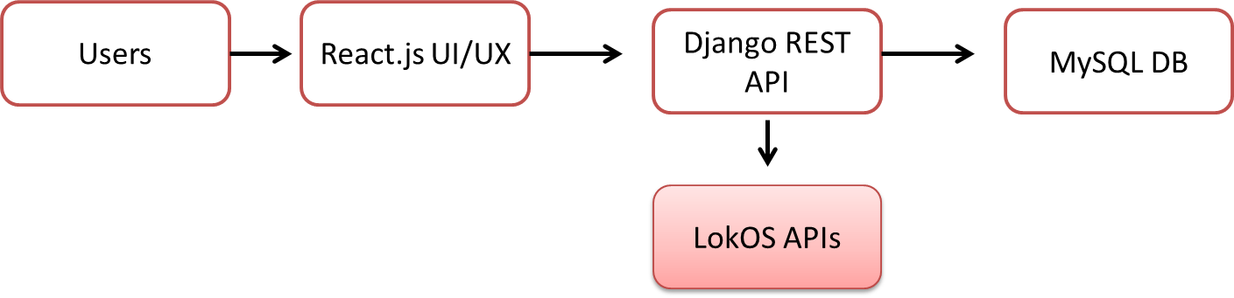
  - External Interfaces
- LokOS Beneficiary APIs
- LokOS SHG & Geography APIs
- Internal Pragati Setu APIs

  - User Interface Overview
- Beneficiary List View
- Beneficiary Profile Detail View
- Module Linkage Tabs
- Export & Reports

- SYSTEM FEATURES
- Beneficiary Master Management
- LokOS Synchronization
- Field Data Enrichment
- Active SHG Enforcement
- Cross-Module Visibility

  - FRONTEND REQUIREMENTS
    - General UI Requirements
- React functional components
- Role-based navigation
- Pagination up to 50,000 records
    - Accessibility
- WCAG 2.1 AA
- Hindi & English support
    - Navigation
- Breadcrumbs
- Filter persistence

  - ER – Diagram
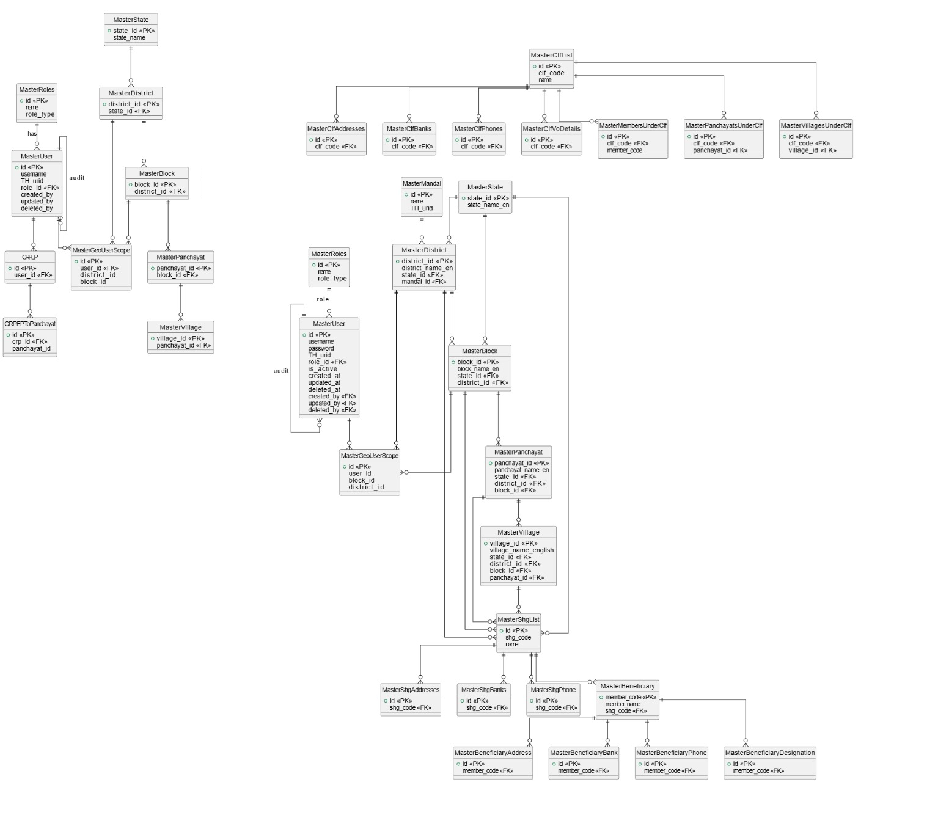

- DATABASE REQUIREMENTS
- MySQL 8.x, InnoDB
- 3NF normalization
- Soft delete only
- Full audit fields

  - SYSTEM WORKFLOWS
    - LokOS Sync Workflow
- Scheduled API fetch
- Validation
- Active SHG filter
- Upsert beneficiary
    - Field Enrichment Workflow
- Authorized edit
- Validation
- Audit logging
- FUNCTIONAL REQUIREMENTS (BMS)
  - FR-AUTH
- Secure login
- Role enforcement
  - FR-BMS-01 Beneficiary Retrieval
- SHALL fetch only active SHG members
- SHALL restrict by jurisdiction
  - FR-BMS-02 Beneficiary Profile
- SHALL display only approved headers
- SHALL lock LokOS fields
  - FR-BMS-03 Data Enrichment
- Aadhaar
- Bank loan status
- Cadre role
  - FR-BMS-04 Cross-Module Visibility
- Enterprise
- Lakhpati Didi
- TMS

- NON-FUNCTIONAL REQUIREMENTS
- 2,000 concurrent users
- <2 sec API response (95%)
- 99% uptime
- Encrypted sensitive data

  - DATA AND DATABASE REQUIREMENTS
- Beneficiary
- SHG
- Location hierarchy
- Module mapping tables

  - INTERFACES AND INTEGRATION
    - Authentication & users
- Login / logout / session
  - POST /api/auth/login/ – username, password → returns token / session info.
  - POST /api/auth/logout/ – invalidates token / session.
- Current user
  - GET /api/auth/me/ – profile + role (BMMU / DMMU / SMMU).
  - PATCH /api/auth/me/ – update own name, email, mobile, etc.
- User admin
  - GET /api/users/
  - POST /api/users/
  - GET /api/users/{id}/
  - PATCH /api/users/{id}/
  - DELETE /api/users/{id}/

    - Master data (location hierarchy & SHGs)
- District
- GET /api/districts/
- GET /api/districts/{id}/
- Optional admin: POST, PATCH, DELETE on /api/districts/ and /api/districts/{id}/.
- Block
- GET /api/blocks/
- GET /api/blocks/{id}/
- Mandal / Gram Panchayat / Village
- GET /api/mandals/
- GET /api/gram-panchayats/
- GET /api/villages/
- Each with ?district_id= / ?block_id= filters.
- SHG
- GET /api/shgs/ – list with filters ?district_id=&block_id=&search=...
- POST /api/shgs/ – create new SHG.
- GET /api/shgs/{id}/
- PATCH /api/shgs/{id}/
- DELETE /api/shgs/{id}/
    - Beneficiaries
- Beneficiary CRUD
- GET /api/beneficiaries/
  - Filters: ?district_id=&block_id=&mandal_id=&village_id=&shg_id=&search=&category=&page=&page_size=.
- POST /api/beneficiaries/ – create.
- GET /api/beneficiaries/{id}/ – full detail.
- PATCH /api/beneficiaries/{id}/ – partial update.
- DELETE /api/beneficiaries/{id}/ – delete.

- Bulk operations / import-export
- POST /api/beneficiaries/bulk-delete/ – body: {ids: [ ... ]}.
- POST /api/beneficiaries/import/ – upload Excel/CSV, same logic you already have in bmmu_dashboard import.
- GET /api/beneficiaries/export/ – returns XLSX/CSV.
    - CONSTRAINTS & STANDARDS
- GIGW 3.0
- ISO 27001 aligned logging
- Government UI guidelines

- ERROR HANDLING
- HTTP 400 / 403 / 500
- React toast notifications

  - AUDIT & LOGGING
- Immutable audit trail
- User, timestamp, before/after

- DEPLOYMENT REQUIREMENTS
- Django + Gunicorn
- Nginx
- MySQL

  - VALIDATION & ACCEPTANCE
- FR-wise test cases
- Security & performance benchmarks

  - CLOSURE
This SRS establishes the official baseline for BMS implementation under Pragati Setu. Any modification shall follow formal change control.

Disclaimer
- By reading the report, the reader accepts the terms and conditions mentioned hereunder.
- The scope of assignment is as per Contract between Third Party Auditor (BDO India LLP) and UPSRLM.
- This Report (“Report”) is prepared solely for the UP State Rural Livelihoods Mission (UPSRLM). This Report is intended for UPSRLM’s internal use only, subject to the terms and conditions mentioned therein may not be relied upon by other parties (“Third Party”). Neither this Report nor its contents may be distributed to, discussed with, or otherwise disclosed to any Third Party without the prior written consent of BDO India LLP (“BDO India” or “we” or “our” or “us”). Any other persons who choose to rely on these observations may do so entirely at their own risk.
- Our procedure and findings are based solely on the data, documentation, information and explanation that had been provided to us during the course of our engagement. In case, we come across information which may have bearing on the findings and observation made in this report subsequent to submission of report, we have no responsibility to update this Report. In circumstances, where any additional information becomes available from or with respect to the engagement to us, we would be glad to carry out additional procedure as may be separately agreed with the Client.
- The work carried out and analysis presented in this report is based on the result of our discussion with representatives of UPSRLM and are not always supported by written documentation. We make no representation regarding the sufficiency of the procedures performed either for the purpose for which this engagement was sought or for any other purpose. Findings are based on circumstantial evidence and partially concluded in the absence of adequate supporting / documents.
- We have relied on the information provided by the UPSRLM and our observations are based primarily on the review of such information. In respect of the information in soft copy form received from the UPSRLM, no independent verification with the original documents is carried out.
- This Report does not constitute an engagement to provide audit, compilation, review, or attestation services made in accordance with the generally accepted auditing standards in India and, consequently, no assurance will be expressed. Our work would not be any expression of an opinion or testimony of expert witness. In any manner, the engagement does not extend to provide advice, analysis and observations relating to legal and regulatory issues.
- In no circumstances shall we be liable, for any loss or damage, of whatsoever nature, arising from information material to our work being withheld or concealed from us or misrepresented to us by any person of whom we made information requests at the bank or on field.
- BDO India LLP has executed detailed work steps as identified and agreed in our scope of work.
- We assume no responsibility for the accuracy and completeness of information, that cost/benefit and other considerations will preclude us from pursuing every conceivable source of information. Further, we have used professional judgment to identify the information source to be searched. If other professional undertook similar procedures on the same subjects, such professionals might provide different findings. Accordingly, we do not provide assurance that all information will be available in the public and private domain.
- UPSRLM shall be fully and solely responsible for applying independent judgment, with respect to the findings included in this Report, to make appropriate decisions in relation to the future course of action, if any. BDO India shall not take responsibility for the consequences resulting from decisions based on information included in the report.
- BDO has not identified, addressed or corrected any errors or defects in the computer systems, other devices or components thereof (“Systems”), whether or not due to imprecise or ambiguous entry, storage, interpretation or processing or reporting of data. We will not be responsible for any defect or problem arising out of or related to data processing in any Systems.
- Our reports and comments should not be considered a definitive pronouncement on the individual or the company.
- When assisting the Client in the Performance of BDO India’s activities, BDO India has not:
- Determined which, if any, recommendations should be implemented;
- Acted on behalf of management in reporting to the Board of Directors, or Audit Committee;
- Have custody of assets;
- Act in any capacity equivalent to a member of management or an employee;
- Assess the quality of source data;
- Held liable, for any loss or damage, of whatsoever nature, arising from analysis.
- Approved, or be responsible for, the overall fraud risk assessment work, including the ultimate assessment of review risk, determination of scope, project priorities and frequency of Performance of audit procedures.

WHAT MATTERS TO YOU,
MATTERS TO US.

FOR MORE INFORMATION:
Anurag Srivastava- Partner
+91 – 9717004947| AnuragSrivastava@bdo.in

BDO INDIA LLP, an Indian limited liability partnership, is a member of BDO International Limited, a UK company limited by guarantee, and forms part of the international BDO network of independent member firms.

BDO is the brand name for the BDO network and for each of the BDO Member Firms.
Copyright © Aug 2021, BDO INDIA LLP. All rights reserved.
www.bdo.in

